First Light Farm
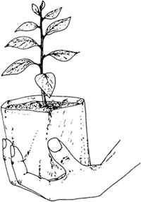
Little Green Thumbs
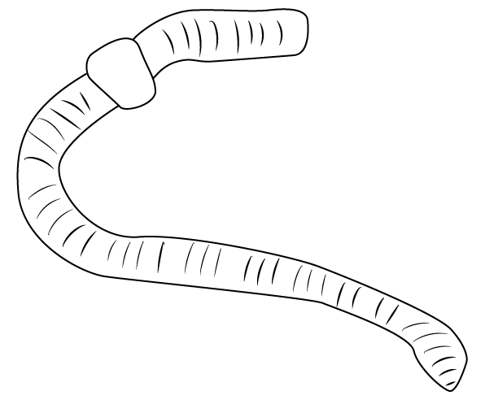
Summer Program
AGES: Pre-K-1st Grade; older children are welcome as helpers!
DATES: June 29th, July: 13th, 20th, 27th, Aug: 3rd, 10th, 17th, 24th
LENGTH: 60 minute program with optional BYO-Picnic.
TIME: 10:30am-11:30am; 11:30am-12pm optional BYO-Picnic.
COST: $10 members/$15 non-members. Extra children are $5 each. Includes program cost and small CSA bag for child with activity, nutrition tid-bit, and family-friendly recipe involving bag contents.
**Limit 12 children per program day

We invite children and families to visit our sustainable farm to explore the beauty of mother nature. Our joyous summer exploration series at the farm allows young children to learn about farm favorites – composting, flowers and bees, planting seeds – with hands-on experiences, singing, reading, and crafts while growing a sense of togetherness as a community.

June 29th: All about Seeds!
July 13th: Composting Fun! (children make a mini-compost bin to take home )
July 20th: Eating the Rainbow! This lesson will include focus on diversity, fairness, and equity (Please bring a family photo!).
July 27th: Flowers and Bees!
August 3rd: Exploring the Senses!
August 10th: Pickling and Making Chicken Feed!
August 17th: Herbs and Fairies!
August 24th: We come together and make “Stone Soup” for our final program.
Please email Jackie at firstlightfarm84@gmail.com to sign up!
We look forward to seeing you at the farm!
___________________________________________
First Light Farm is located at 1202 West Snoqualmie River Rd NE, Carnation 98014.
“Healthy Soils, Healthy Families, Healthy Communities”

